**Mealwroms in *Edible insects: Future Prospect for food and feed securit*  report**

*I put the highlighted report on teambition. Everything is compiled here (I re-highlighted in yellow what directly involve mealworms) and put the number of the PDF pages if you need to have a look.*

*My suggestions are* ***in red***

**=> Here is the plan of the big sequences addressed in the introduction of the FAO report. We should also address these aspects in our final report (between brackets what we shall leave apart)**

THE ROLE OF INSECTS **(of mealworms for us, the 3 different species of them with pictures and explanations of what they are)**

CULTURE **(data for Mexico, Thailand, China, and recently Belgium & Netherlands - cf what follows)**

ENVIRONMENTAL OPPORTUNITIES **(environmental requirements + can be raised on organic waste cf what follows)**

(INSECTS AS A NATURAL RESOURCE) **–shall we study where wild mealworms are and whether they are threatened ?**

p.16

NUTRITION FOR HUMAN CONSUMPTION **(quantified data later in the report)**

Insects are a highly nutritious and healthy food source with high fat, protein, vitamin, fibre and mineral content. The nutritional value of edible insects is highly variable because of the wide range of edible insect species. Even within the same group of species, nutritional value may differ depending on the metamorphic stage of the insect, the habitat in which it lives, and its diet. For example, the composition of unsaturated omega-3 and six fatty acids in mealworms is comparable with that in fish (and higher than in cattle and pigs), and the protein, vitamin and mineral content of mealworms is similar to that in fish and meat.

FARMING SYSTEMS **(quantitative description of the current pattern)**

Most edible insects are harvested in the wild.

The concept of farming insects for food is, however, relatively new.

In temperate zones, insect farming is performed largely by family-run enterprises that rear insects such as mealworms, crickets and grasshoppers in large quantities, mainly as pets or for zoos. Some of these firms have only recently been able to commercialize insects as food and feed, and the **part of their production intended for direct human consumption is still minimal.**

A few industrial-scale enterprises are in various stages of start-up for rearing mass quantities of insects such as black soldier flies. They are mainly for consumption as whole insects or to be processed into meal for feed. Critical elements for successful rearing include **research on biology, rearing condition control and diet formulas** for the farmed insect species. Current production systems are **expensive**, with **many patents pending.** A **major challenge of such industrial-scale rearing** is the **development of automation processes to make plants economically competitive with the production of meat** (or meat-substitutes like soy) from traditional livestock or farming sources.

INSECTS AS ANIMAL FEED **(specific part on it later on)**

PROCESSING **(Max ?)**

FOOD SAFETY AND PRESERVATION

LIVELIHOOD IMPROVEMENT

ECONOMIC DEVELOPMENT

COMMUNICATION

LEGISLATION

THE WAY FORWARD

p.28 [mealworms belong to the major group of edible insects: beetles (or coleoptera), which account for 40% of known insect species.]

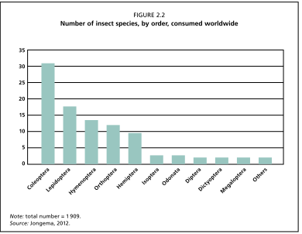

p.29

Mostly eaten beetles: 78 edible aquatic beetles (usually larvaes) + plam weevil

In the Netherlands, the larvae of mealworm species from the Tenebrionidae family, such as the yellow mealworm (Tenebrio molitor), the lesser mealworm (Alphitobius diaperinus) and the superworm (Zophobas morio), are reared as feed for reptile, fish and avian pets. They are also considered particularly fit for human consumption and are offered as human food in specialized shops.

p.76-77

5.2 ORGANIC SIDE STREAMS

A benefit of insects as an alternative animal protein source is that they can be reared sustainably on organic side streams (e.g. manure, pig slurry and compost). The use of organic side streams in insects starts by rearing the insects on biowaste. The insects are processed and fed to a specific animal (Figure 5.2), the meat of which is then sold to the consumer (Veldkamp et al., 2012) (see Chapter 8).

Insect species such as the black soldier fly (Hermetica illucens), the common housefly (Musca domestica) and the yellow mealworm (Tenebrio molitor) are very efficient at bioconverting organic waste. For this reason, these species are receiving increasing attention, as they could collectively convert 1.3 billion tonnes of biowaste per year (Veldkamp et al., 2012). Other insect species, such as crickets, are raised on insect farms and fed with high-quality feed such as chicken feed. The substitution of such feed with organic side streams can help to make insect farming more profitable (Offenberg, 2011). However, at present this is not permitted because of food and feed legislation (see Chapter 14).

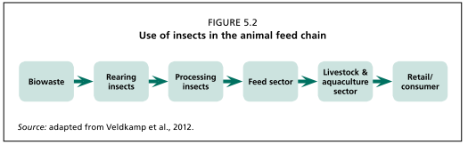

Recycling agricultural and forestry wastes into feed greatly reduces organic pollution.

According to DeFoliart (1989), “Practically every substance of organic origin, including cellulose, is fed upon by one or more species of insects, so it is only a matter of time before successful recycling systems will be developed”. The possibility of rearing insects on organic waste for human consumption is still being explored, given the unknown risks of pathogens and contaminants (Box 5.1)

[In 2004, a project co-financed by the European programme LIFE titled **Ecodiptera** was launched to make better use of the huge volume of pig manure generated across Europe. [...] In Slovakia, a pilot plant for the biodegradation of pig slurry was developed with fly larvae by adapting existing technology for chicken manure. Methods suitable for the maintenance of colonies of flies and the identification of optimal conditions were developed. The project found that when flies reach the pupal stage they can be used as protein feed in aquaculture. [...] ]

**=> could be useful to know what happened with this project. Will it help make the law evolve?**

p.79

Yet insects deemed viable for human consumption in the Western world include species such as mealworm larvae, crickets and locusts, which compare favourably with pigs and beef cattle in their GHG emissions (they are lower by a factor of about 100) (Oonincx et al., 2010) (Figure 5.4).

Livestock waste (urine and manure) also contributes to environmental pollution (e.g. ammonia) that can lead to nitrification and soil acidification (Aarnink et al., 1995). **[just to quote I think]**

Mealworm larvae, crickets and locusts also compare favourably to pigs in ammonia emissions, as shown in Figure 5.4 (about a tenfold difference) (Oonincx et al., 2010). These results are taken from small-scale experiments performed in laboratories and caution should be exercised in making comparisons with large-scale pork and beef production.

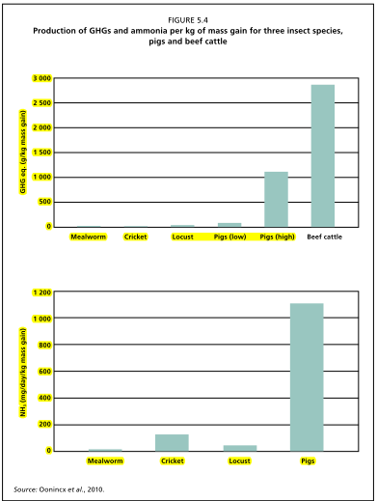

5.4 Water use

Water is a key determinant of land productivity.

Mealworms, for example, are more drought-resistant than cattle (the growing efficiency of mealworms in the presence of sufficient water is described in section 6.1).

5.5. Life cycle analysis

Life cycle assessment is a technique to assess the environmental impacts associated with all stages of a product’s life, but of the edible insects only mealworms have been assessed in this way. Oonincx and de Boer (2012) quantified GHG production (GWP), energy use and land-use area throughout the mealworm production chain and found that energy usage for the production of 1 kg of mealworm protein was lower than for beef, comparable with pork, and slightly higher than for chicken and milk. GHG emissions due to mealworm production were much lower than for the more common production animals (Figure 5.5). For every 1 ha of land required to produce mealworm protein, 2.5 ha would be required to produce a similar quantity of milk protein, 2–3.5 ha would be required to produce a similar quantity of pork or chicken protein, and 10 ha would be required to produce a similar quantity of beef protein. On the basis of this study, therefore, mealworms are a more environmentally friendly source of animal protein than milk, chicken, pork and beef.

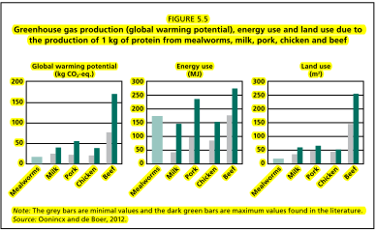

5.6 Animal welfare **[another issue we might investigate]**

To ensure animal welfare, farmed insects should be provided with adequate space, which depends on the level of interaction a species has with conspecifics (other organisms of the same species) under natural conditions. Mealworms also have a tendency to cluster

p.84-85

6.1.1 Dietary energy

Ramos Elorduy et al. (1997) analysed 78 insect species from Oaxaca state, Mexico, and determined that caloric content was 293–762 kilocalories per 100 g of dry matter.

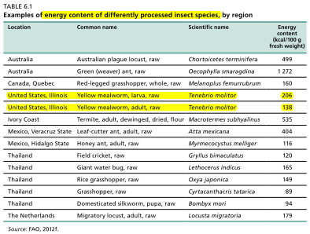

6.1.2 Protein

General information about protein in box 6.2: **[can be good to make such a reminder in our report]**

Proteins are organic compounds consisting of amino acids. They are important elements of food nutrition but also contribute to its physical and sensory properties. The nutritive value depends on several factors: protein content, which varies widely among all foods; protein quality, which depends on the kind of amino acids present (essential or non-essential) and whether the quality complies with human needs; and protein digestibility, which refers to the digestibility of the amino acids present in the food.

Amino acids are the building blocks required for the biosynthesis of all proteins through human metabolism to ensure proper growth, development and maintenance.

Essential amino acids are indispensable because the body cannot synthesize them and so must obtain them through food. Eight amino acids are classified as essential: phenylalanine, valine, threonine, tryptophan, isoleucine, methionine, leucine and lysine.

Xiaoming et al. (2010) evaluated the protein content of 100 species from a number of insect orders.

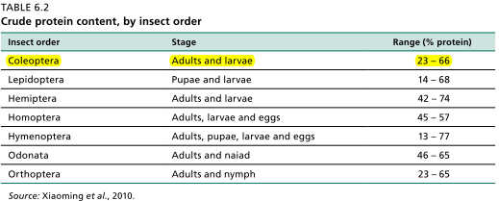

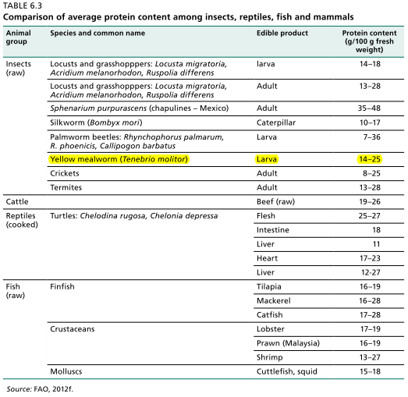

p.89-90

6.1.7 Vitamins

Vitamins essential for stimulating metabolic processes and enhancing immune system functions are present in most edible insects. Bukkens (2005) showed for a whole range of insects that thiamine (also known as vitamin B1, an essential vitamin that acts principally as a co-enzyme to metabolize carbohydrate into energy) ranged from 0.1 mg to 4 mg per 100 g of dry matter. Riboflavin (also known as vitamin B2, whose principle function is metabolism) ranged from 0.11 to 8.9 mg per 100 mg. By comparison, wholemeal bread provides 0.16 mg and 0.19 mg per 100 g of B1 and B2, respectively. Vitamin B12 occurs only in food of animal origin and is well represented in mealworm larvae, Tenebrio molitor (0.47 µg per 100 g)

The levels of these vitamins (Retinol and β-carotene (vitamin A)) were less than 20 µg per 100 g and less than 100 µg per 100 g in yellow mealworm larvae, superworms and house crickets (Finke, 2002; Bukkens, 2005; Oonincx and Poel, 2011).

Generally, insects are not the best source of vitamin A (D. Oonincx, personal communication, 2012).

Vitamin E to be investigated for mealworms

p.90-91-92

6.2 Beef vs insects: an example of the mealworm

Finke (2002) explored the nutritional value of several insect species, including the yellow mealworm (Tenebrio molitor). The larvae of the beetle have been mentioned as a promising option for mass rearing in Western countries because the species is endemic in temperate climates and easy to farm on a large scale, it has a short life cycle, and farming expertise is already available, particularly in the pet food industry. In the study by Finke (2002), insects were fasted for 24 hours to void their intestinal tract. The following conclusions were made (on a dry weight basis except for moisture and energy):

• Macronutrient composition. The fat content of beef is higher than that of mealworm larvae. Beef has slightly lower moisture content than mealworms and is marginally higher in protein and metabolizable energy.

• Amino-acids. Beef is higher in a.o. glutamic acid, lysine and methionine and lower in a.o. isoleucine, leucine, valine, tyrosine and alanine, compared with mealworms.

• Fatty acids: Beef contains more palmitoleic, palmitic and stearic acid than mealworms, but far higher values in essential linoleic acids were present in mealworms. Howard and Stanley-Samuelson (1990) analysed the phospholipid fatty acid composition of the adult T. molitor and found that over 80 percent of these fatty acids consisted of palmitic, stearic, oleic and linoleic acids. Finke (2002) found the same fatty acids in high amounts in T. molitor larvae. Polyunsaturated fatty acids are mostly found as phospholipids (Howard and Stanley-Samuelson, 1990).

• Minerals. Mealworms contain comparable values of copper, sodium, potassium, iron, zinc and selenium.

• Vitamins. Mealworms have generally higher vitamin content than beef, with the exception of vitamin B12.

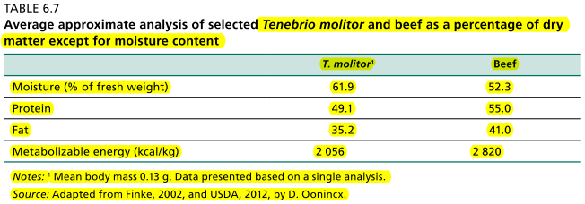

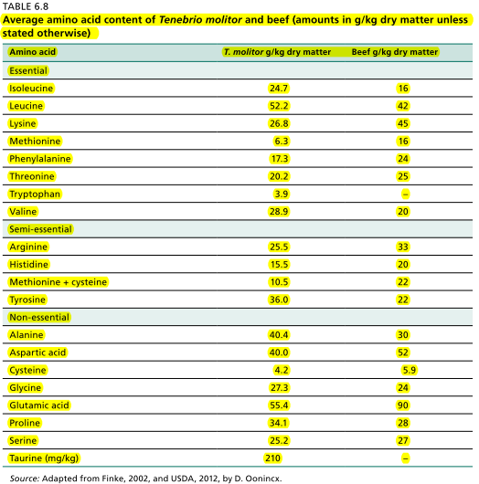

The extent to which generalizations can be made about the nutrient content of T. molitor, presented in tables 6.7, 6.8 and 6.9, is limited, since data were from a single study and insect growth and development and nutritional composition depend on the specific diet of the insect (Davis and Sosulski, 1974; Anderson, 2000; Finke, 2002).

Tenebrio molitor larvae, for example, need a dietary carbohydrate concentration of at least 40 percent to develop, and optimal growth is reached when the insect is grown on diets containing 70 percent carbohydrates (Behmer, 2006). Additionally, larvae grow and develop faster when a water source is available than when reared on dry food only (Urs and Hopkins, 1973a). Larvae reared in the presence of moisture are, moreover, heavier; this difference in weight is due not to higher water content but to a higher fat content because although insects can be fed on low-value organic waste streams it will affect their nutritional values, resulting in values lower than shown in tables 6.8 and 6.9.

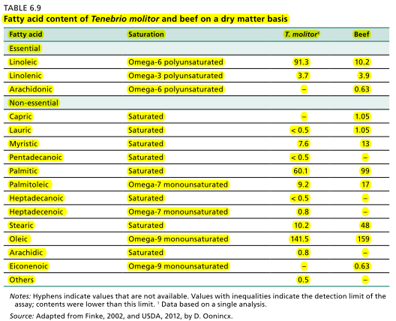

p.93

In Mexico, for example, it is not uncommon to find tortillas enriched with yellow mealworms, a traditional source of protein (Aguilar-Miranda et al., 2002) (Box 6.5).

**Don Bugito: creative and traditional Mexican food cart**

**(Serves as a good example for cultural promotion)**

Monica Martinez is a 36-year-old artist. Using art as a means, she wants to convince people to consider insects as a viable food source. This is the driving factor behind Don Bugito – launched in 2011 – a street food cart project which sells edible insect treats that are healthy for both people and the planet at street parties, festivals and food fairs. Inspired by prehispanic and contemporary Mexican cuisine, Don Bugito features a creative and traditional use of edible insects, grown organically and naturally in California, where Martinez is based. “San Francisco’s foodie culture and its large Asian and Latino communities – whose cuisines already include edible insects – make the city a natural testing ground,” says the artist. The cart features familiar Mexican ingredients – soft, blue corn tortillas, chilies and cheeses – along with protein-rich insects also found in prehispanic fare. The plump larvae of the wax moth fill tacos, along with peppers and a mint-cilantro salsa (Campbell, 2011). Martinez serves additional toasted crickets and, for dessert, caramelized mealworms on top of Mexican vanilla ice cream.

p.108 (Insects as animal feed)

7.2.1 Poultry

In South Kivu, the Democratic Republic of the Congo, Munyuli Bin Mushambanyi and Balezi (2002) explored the possibility of replacing extremely expensive meat meal – a 20 percent feed ingredient in poultry farming – with flour derived from cockroaches (Blatta orientalis) and termites (Kalotermes flavicollis). Their study showed that the **insect-derived flour could replace the meat meal ingredient when incorporated in the feed**. Ramos Elorduy et al. (2002) conducted similar experiments with mealworms (Tenebrio molitor), rearing them on low-nutritive waste products and feeding them to broiler chickens. The mealworms were able to transform the low-nutritive waste products into a high-protein diet, making T. molitor a promising source of alternative protein, in particular as a replacement of soybean meal in poultry feed. Similar results were found in trials with Anabrus simplex, Acheta domesticus, Bombyx mori, Alphitobius diaperinus, Tribolium castaneum and termites (Ramos Elorduy et al., 2002).

p.109

7.3 Key Insect species Used as Feed

Among the most promising species for industrial feed production are black soldier flies, common housefly larvae, silkworms and yellow mealworms.

p.112

7.3.5 Mealworms

Mealworms (such as Tenebrio molitor) are already raised on an industrial scale. They can be grown on low-nutritive waste products and fed to broiler chickens. Ramos Elorduy et al. (2002) reared T. molitor larvae on several dried waste materials of different origins. They used three levels of larvae (0, 5 and 10 percent dry weight) in a 19 percent protein content sorghum–soybean meal basal diet to evaluate feed intake, weight gain and feed efficiency. After 15 days there were no significant differences between treatments. Mealworms are promising alternatives to conventional protein sources, particularly soybean meal.

p.114 (Farming insects), 116, 117, 118, 119

Some insect species are reared for the pet-food industry. For example, mealworms [...]

In temperate regions there are companies that produce large numbers of insects as pet food and fish bait. The species most used are crickets (Gryllodus sigillatus, Gryllus bimaculatus and Acheta domesticus), mealworms (Zophobas morio, Alphitobius diaperinus and Tenebrio molitor), locusts (Locusta migratoria), sun beetles (Pachnoda marginata peregrine), wax moths (Galleria mellonella), cockroaches (Blaptica dubia) and maggots of the housefly (Musca domestica). Some companies even produce Mighty Mealys ™, or giant mealworms, which are T. molitor larvae treated with juvenile hormones. The hormone suppresses pupation and allows the larvae to grow to a size of about 4 cm, making them ideal as pet food and bait.

8.3.2 Temperate zones

In temperate zones, insect farming is largely performed by family-run enterprises that rear insects such as mealworms, crickets and grasshoppers in large quantities for pet food. Because the species are frequently reared in close, confined spaces, climate control is often applied, as high temperatures may cause the desiccation of soft-bodied larvae.

The rearing of high quantities of insects, either for consumption as whole insects and/or as protein extracts, is possible in industrialized countries. Critical elements for successful rearing include greater knowledge of biology, rearing conditions and artificial diet formulation (Wang et al., 2004, Feng and Chen, 2009; Schneider, 2009). Diets can be altered to increase nutritional value (Anderson, 2000) and adapting the light regime can optimize production;

8.4 Insect Farming for Feed

Insects are much more efficient in converting feed to body weight than conventional livestock and are particularly valuable because they can be reared on organic waste streams (e.g. animal slurries). Research into rearing insects as food and feed on a large scale remains a priority. Current production systems are still too expensive. A study in the Netherlands (Meuwissen, 2011) suggested that the production of mealworms is still 4.8 times as expensive as normal chicken feed. In particular, labour and housing costs for large-scale feed production facilities are much higher for insects than for the production of chicken feed.

8.5 Recommendations On Insect Farming

The **Expert Consultation Meeting on Assessing the Potential of Insects as Food and Feed in Assuring Food Security**, held at FAO headquarters in Rome in January 2012, made recommendations for rearing insects, including suggestions on species and strain collection; household production; training in insect farming; the choice, cost and reliability of feedstock; safety, health and environmental issues; and strategic issues for industrial-scale insect farmers.

**(would be cool to know more about that)**

Industrial-scale production was defined in the meeting as a **minimum reach of 1 tonne per day of fresh-weight insects**. Species destined for mass production, moreover, should possess certain characteristics, including a high intrinsic rate of increase; a short development cycle; high survival of immatures and high oviposition rate; a high potential of biomass increase per day (i.e. weight gain per day); a high conversion rate (kg biomass gain per kg feedstock); the ability to live in high densities (kg biomass per m 2 ); and low vulnerability to disease (high resistance). Good candidates were considered to be the black soldier fly (Hermetia illuscens) for feed and the yellow mealworm (Tenebrio molitor) for both food and feed. Because of the vulnerability of production systems, **heavy reliance on a single species is discouraged (Box 8.4)**. **=> then shall we think about a combination of mealworms and soldier flies (for ex)?**

Finally, it was recommended to preserve parental genetic lines in case of culture crashes.

p.121-122

9. Processing edible insects for food and feed

9.1 Different types of consumable products

After being wild-harvested or reared in a domesticated setting, insects are killed by freeze-drying, sun-drying or boiling. They can be processed and consumed in three ways: as whole insects; in ground or paste form; and as an extract of protein, fat or chitin for fortifying food and feed products. Insects are also fried live and consumed.

In countries where edible insects are traditionally eaten, food habits have shifted towards Western diets. To counter this, initiatives have been undertaken, for example, in Mexico, where tortillas are being enriched with yellow mealworm (Aguilar-Miranda et al., 2002). This section gives examples of innovative projects that have developed promising edible insect products.

Buqadilla

Buqadilla is an innovative snack under development for the **Dutch market**. It is a spicy Mexican leguminoceous food product made of chickpeas and lesser mealworms (40 percent). It was well received in several restaurants and canteens, where the product was tested, for its taste and smooth structure. The sustainable, healthy and exotic snack is an example of an accessible and culturally acceptable way for Western consumers to experience and appreciate edible insects as food (van Huis, van Gurp and Dicke, 2012).

Crikizz

Crikizz is another example of European products made with insects. Developed by **Ynsect** and French students, Crikizz are spicy, popped snacks based on mealworms and cassava. The mealworm composition varies from 10 to 20 percent in accordance with the product line (“classic” to “extreme”). According to focus groups, the taste is very pleasing and differs from other snacks, while the texture is as crunchy as other snacks. The prototype was made without preservatives or taste enhancers, and the high fat composition of mealworms removes the need for added fat. Crikizz won a prize in

the national French contest Eco-trophélia 2012 for culinary innovation.

Processed mealworms for pet food, animal feed and human food

HaoCheng Mealworm Inc. in China specializes in the farming and sale of mealworms, superworms and maggots. The farm, established in 2002, consists of 15 rearing facilities and produces 50 tonnes of living mealworms and superworms per month. HaoCheng exports 200 tonnes of dried mealworms to Australia, Europe, North America and Southeast Asia each year.

The mealworms, superworms and maggots are sold live, dried, canned and in powder form. They have elevated protein content and can be used as additives for food as well as feed:

• Food. Mealworm powder can be worked into bread, flour, instant noodles, pastries, biscuits, candy and condiments. The insects can also be consumed whole as meals and side dishes, or processed into medicinal supplements to fortify the human body’s immune system.

• Feed. Entire insects can be used as direct feeds and feed supplements for pets such as birds, dogs, cats, frogs, turtles, shrimps, scorpions, chilopods, ants, goldfish and wild animals (Hao Cheng Mealworm Inc., 2012).

p.128-129

Box 9.3 Application of edible insects: insects as the missing link in designing a circular economy

**[SUPER INTERESTING, more details in the report. We can investigate it on mealworms specifically]**

To satisfy the growing demand for sufficient affordable and sustainable proteins [...] following innovation processes are proposed:

• Insects as bioconverter [...]

• alternative designs for a viable and sustainable agricultural sector.

• Opportunity for innovative modern entrepreneurs.

The potential for marketing insect-derived products depends on the following conditions:

• reliable high volumes of production;

• fair and competitive market prices;

• resolutions to hurdles in legislation;

• permission to use (organic) waste or byproducts from the food and agricultural industry.

The major challenges are:

• scaling up.

• Increased market and consumer acceptance.

• Legislative national and international frameworks.

• Legislative national and international frameworks.

10. Food safety and preservation

Refrigeration is also recommended for fried and boiled insects.

In humid areas, however, even sun-dried caterpillars are susceptible to moisture, which can stimulate the growth of microbes. Insects can also be re-contaminated during the drying process through air or soil; for this reason, hygienic practices during processing are of great importance and an additional heating/cooling step is recommended before consumption (Amadi et al., 2005; Giaccone, 2005).

At household level, fresh insects should be prepared hygienically and sufficient heat treatment applied to ensure a microbiologically safe food product. Other simple preservation methods such as acidifying the insects with vinegar have been successful. Another example is the use of insects for protein enrichment in fermented food products. This is a viable processing option with mutual beneﬁts, since the decreased pH in lactic acid-fermented products prevents the growth of potentially harmful micro-organisms (Klunder et al., 2012).

There has been some success in processing and commercializing insects in the Netherlands. Three insect species (yellow mealworm larvae, lesser mealworm larvae and migratory locusts) can be found in specialized shops in the country that are produced and processed specifically for human consumption. One-day fasting is applied to ensure that the insect has an empty gut (degutting), and the insect is then freeze-dried whole. This produces a safe product with a relatively long shelf life (one year), if stored appropriately in a cool, dry place. Additional advantages of freeze-drying are the maintenance of the insect’s nutritional value and the capacity of the product to re-absorb water. Nevertheless, obstacles remain: freeze-drying is expensive and often results in undesirable oxidation of the long-chained unsaturated fatty acids, decreasing the nutritional value of the product and resulting in “off” odours and tastes.

A host of other contemporary preservation methods should be explored, such as the application of ultraviolet light and high-pressure technologies, as well as adequate packaging methods. Other important considerations need to be made in selecting the preservation method: the capacity to prolong shelf life (and in turn, contain costs), particularly if large amounts of insects need to be processed simultaneously; the extent to which the process preserves the nutritional value of the insects; and the cultural acceptability of the chosen preservation/processing method.

10.2.1 Microbial safety

p.133

The importance of hygienic handling and correct storage was highlighted by Klunder et al. (2012) in a laboratory experiment looking at the microbiological content of farmed yellow mealworm larvae (Tenebrio molitor) and house crickets (Acheta domesticus). Boiling the insects in water for a few minutes eliminated Enterobacteriacae, but spores were found to survive this process, with the potential that the spores could germinate and the bacteria grow given favourable conditions, such as temperatures around 30 °C and a moist environment, causing food spoilage. The spore-forming bacteria were found in the insect gut and on the skin and are likely to have been soil-borne. Alternative preservation techniques that do not involve the use of a refrigerator are drying and acidifying. Lactic fermentation of composite flour/water mixtures containing 10–20 percent powdered roasted mealworm larvae resulted in successful acidification and was demonstrated to be effective in safeguarding shelf life and safety by the control of enterobacteria and bacterial spores.

In another experiment, chemical–physical and microbiological analyses of the following five insect species with rearing potential were carried out: superworm (Zophobas morio), yellow mealworm (Tenebrio molitor), wax moth (Galleria melonella), butterworm (Chilecomadia moorei) and house cricket (Acheta domesticus). Neither Salmonella nor Listeria monocytogenes were identified in the analysed samples and it was concluded that it is unlikely that these insects attract microbial flora that pose risks to humans. However, it is still recommended that insects undergo a transformation to render inactive or reduce their microbial content. This could involve cooking (e.g. boiling or roasting) or pasteurization (Giaccone, 2005).

p.136

10.2.4. Inorganic contamination **(this can help us to show why it’s better to rear them than harvest them)**

Harmful metals from the environment have been found in the cells of several insect body parts – such as the fat, integument (exoskeleton), reproductive organs and digestive tracts – where they bio-accumulate. A study on the yellow mealworm larvae (Tenebrio molitor), for example, showed that the insects accumulate cadmium and lead in their bodies when they feed on organic matter in soils that contain these metals (Vijver et al., 2003). However, Lindqvist and Block (1995) showed that after each moult, larvae lose some cadmium, and even larger amounts of the metal are lost after metamorphosis. Further research into the consequences this might have for human consumption is necessary.

p.137

10.3 Allergies

10.3.1 allergic reactions to edible insects

Studies suggest that people frequently in contact with larvae of T. molitor, for example, run the risk of developing certain allergic reactions (Senti, Lundberg and Wüthrich, 2000; Siracusa et al., 2003). The same was found for the closely related species Alphitobius diaperinus. The symptoms of the allergic reactions include inflammation of the eyes and nose (T. molitor) and itching, mild swelling, inflammation of the nose, asthma and skin rash (A. diaperinus) (Schroeckenstein et al., 1988; Schroeckenstein, Meier-Davis and Bush, 1990). Cross reactivity can also occur between the two species, meaning that the antibodies for a specific allergen in one insect species is capable of identifying allergens in another and may thus induce an allergic reaction to that insect as well.

p.144

12. Economics: cash income, enterprise development, markets and trade

In the Netherlands, 50 g of the yellow mealworm and the lesser mealworm costs €4.85,

p.146

Box 12.2 Wholesale market in Thailand

Jatujak market (Bangkok; this market sells mainly mealworms as edible insects for pet feed) (Hanboonsong, 2012).

p.147

Box 12.4 The **dutch Insect Farmers association VENIK** **=> try to contact them!**

The production and sale of edible insects in the Netherlands started with the foundation of the Dutch Insect Farmers Association (VENIK) in 2008. [...] VENIK is building a network at the national and international levels with market parties, knowledge institutions and NGos. It has contacts with policymakers, politicians and the food safety authority. It also provides information on edible insects to professionals, consumers and the media.

Special production lines are already in place to comply with HACCP standards. Three insect species are being produced for human consumption: the yellow mealworm (Tenebrio molitor), the lesser mealworm (Alphitobius diaperinus) and the migratory locust (Locusta migratoria). These insects are sold freeze-dried.

p.151

12.4.3 Insects as pet food

(Back to HaoCheng Mealworm Inc. +)

In the Netherlands, companies that rear insects as pet food now sell mealworms and locusts for human consumption. **Kreca** **(information on that company?)** is an example of such a company. However, mealworms are still a niche market in the human food industry, and these companies survive mainly through the sale of insects as pet food.

p.154

Box 13.2 **edible insect cookbooks** **=> find some nice mealworms receipts**

•Creepy Crawly Cuisine: The Gourmet Guide to Edible Insects, by Julieta Ramos Elorduy

• Eat-a-Bug Cookbook: 33 Ways to Cook Grasshoppers, Ants, Water Bugs, Spiders, Centipedes and their Kin, by David George Gordon

• Man Eating Bugs: The Art and Science of Eating Insects, by Peter Menzel and Faith D’Aluisio

•Het Insectenkookboek (The Insect Cookbook), by Arnold van Huis, Henk van Gurp and Marcel Dicke.

References (to be further investigated)

**Aguilar-Miranda, E.D., Lopez, M.G., Escamilla-Santana, C. & Barba de la Rosa, A.P.**

2002. Characteristics of maize flour tortilla supplemented with ground Tenebrio molitor larvae. Journal of Agricultural and Food Chemistry, 50(1): 192–195.

**Anderson, S. J.**

2000. Increasing calcium levels in cultured insects. Zoo Biology, 19(1): 1-9.

**Behmer, S.T.**

2006. Insect dietary needs: plants as food for insects. Encyclopedia of Plant and Crop Science. UK, Taylor & Francis.

**Bukkens, S.G.F. 1997.**

The nutritional value of edible insects. Ecology of Food and Nutrition, 36: 287–319.

**Bukkens, S.G.F.**

2005. Insects in the human diet: nutritional aspects. In M.G. Paoletti, ed. Ecological implications of minilivestock; role of rodents, frogs, snails, and insects for sustainable development, pp. 545–577. New Hampshire, Science Publishers.

**Chen, X., Feng, Y. & Chen, Z.**

2009. Common edible insects and their utilization in China. Entomological Research, 39(5): 299–303.

**Davis, G.R.F. & Sosulski, F.W.**

1974. Nutritional quality of oilseed protein isolates as determined with larvae of the yellow mealworm, Tenebrio molitor L. The Journal of Nutrition, 104(9): 1172–1177.

**DeFoliart, G.R. (published many other studies that could be useful)**

1989. The human use of insects as food and as animal feed. Bulletin of The Entomological Society of America, 35: 22–35.

**Finke, M.D.**

2002. Complete nutrient composition of commercially raised invertebrates used as food for insectivores. Zoo Biology, 21(3): 269–285.

**Giaccone, V.**

2005. Hygiene and health features of “minilivestock”. In M.G. Paoletti, ed. Ecological implications of minilivestock; role of rodents, frogs, snails, and insects for sustainable development, pp. 579–598. New Hampshire, Science Publishers.

**Hanboonsong, Y. [also worked on cultural aspect of insect eating in Thailand and tourist attraction it represents]**

2012. Edible insect recipes: edible insects for better nutrition and improved food security. Vientiane, FAO and the Government of Lao PDR.

**HaoCheng Mealworm, Inc.**

2012. About HaoCheng Mealworm Inc. (available at www.hcmealworm.com). Accessed November 2012.

**Howard, R.W. & Stanley-Samuelson, D.W.**

1990. Phospholipid fatty acid composition and arachidonic acid metabolism in selected tissues of adult Tenebrio molitor (Coleoptera: Tenebrionidae). Annals of the Entomological Society of America, 83(5): 975–981.

**van Huis, A., van Gurp, H. & Dicke, M.**

2012. Het insectenkookboek. Amsterdam, the Netherlands, Atlas.

**Klunder, H.C., Wolkers-Rooijackers, J., Korpela, J.M. & Nout, M.J.R.**

2012. Microbiological aspects of processing and storage of edible insects. Food Control, 26: 628–631.

**Lindqvist, L. & Block, M.**

1995. Excretion of cadmium during moulting and metamorphosis in Tenebrio molitor (Coleoptera; Tenebrionidae). Comparative Biochemistry and Physiology, 111(2): 325–328.

**Meuwissen, P.**

2011. Insecten als nieuwe eiwitbron: Een scenarioverkenning van de marktkansen. 's-Hertogenbosch: ZLTO projecten.

**Offenberg, J. 2011. => worked on ants more specifically**

Oecophylla smaragdina food conversion efﬁciency: prospects for ant farming. Journal of Applied Entomology, 135(8): 575–581.)

**Oonincx, D.G.A.B. & de Boer, I.J.M.**

2012. Environmental impact of the production of mealworms as a protein source for humans: a life cycle assessment. PLoS ONE, 7(12): e51145.

**Oonincx, D.G.A.B., van Itterbeeck, J., Heetkamp, M. J. W., van den Brand, H., van Loon, J. & van Huis, A.**

2010. An exploration on greenhouse gas and ammonia production by insect species suitable for animal or human consumption. Plos One, 5(12): e14445.

D. Oonincx, personal communication, 2012 **[often refered to but not in the references]**

**Ramos Elorduy, J. [another guy who wrote many papers used as references in the FAO report]**

1997. The importance of edible insects in the nutrition and economy of people of the rural areas of Mexico. Ecology of Food and Nutrition, 36: 347–366.

**Ramos Elorduy, J., Gonzalez, E.A., Hernandez, A.R. & Pino, J.M.**

2002. Use of Tenebrio molitor (Coleoptera: Tenebrionidae) to recycle organic wastes and as feed for broiler chickens. Journal of Economic Entomology, 95(1): 214–220.

**Schneider, J.C. ed.**

2009. Principles and procedures for rearing high quality insects. USA, Mississippi State University.

**Siracusa, A., Marcucci, F., Spinozzi, F., Marabini, A., Pettinari, L., Pace, M.L. & Tacconi, C.**

2003. Prevalence of occupational allergy due to live fish bait. Clinical and Experimental Allergy, 33(4): 507–510.

**Schroeckenstein, D.C., Meier-Davis, S. & Bush, R.K.**

1990. Occupational sensitivity to Tenebrio molitor Linnaeus (yellow mealworm). The Journal of Allergy and Clinical Immunology, 86(2): 182–188.

**Schroeckenstein, D.C., Meier-Davis, S., Graziano, F.M., Falomo, A. & Bush, R.K.**

1988. Occupational sensitivity to Alphitobius diaperinus (Panzer) (lesser mealworm). The Journal of Allergy and Clinical Immunology, 82(6): 1081–1088.

**Senti, G., Lundberg, M. & Wüthrich, B.**

2000. Asthma caused by a pet bat. Allergy, 55(4): 406–407.

**Urs, K.C.D. & Hopkins, T.L.**

1973a. Effect of moisture on growth rate and development of two strains of Tenebrio molitor L. (Coleoptera, Tenebrionidae). Journal of Stored Products Research, 8: 291–297.

**Urs, K.C.D. & Hopkins, T.L.**

1973b. Effect of moisture on the lipid content and composition of two strains of Tenebrio molitor L. (Coleoptera, Tenebrionidae). Journal of Stored Products Research, 8(4): 299–305.

**Veldkamp, T., G. van Duinkerken, A. van Huis, C.M.M. Lakemond, E. and Ottevanger, E., and M.A.J.S van Boekel,**

2012. Insects as a sustainable feed ingredient in pig and poultry diets. A feasibility study. Wageningen UR Livestock Research, Report 638.

**Vijver, M., Jager, T., Posthuma, L. & Peijnenburg, W.**

2003. Metal uptake from soils and soil-sediment mixtures by larvae of Tenebrio molitor (L.) (Coleoptera). Ecotoxicology and Environmental Safety, 54(3): 277–289.

**Xiaoming, C., Ying, F., Hong, Z. & Zhiyong, C.**

2010. Review of the nuritive value of edible insects. In P.B. Durst, D.V. Johnson, R.L. Leslie. & K. Shono, eds. Forest insects as food: humans bite back, proceedings of a workshop on Asia-Pacific resources and their potential for development. Bangkok, FAO Regional Office for Asia and the Pacific.